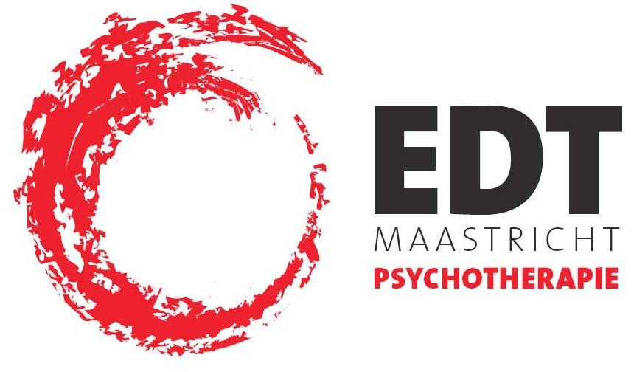

EDT Maastricht
Capucijnenstraat 92
6211 RT Maastricht
043-3210017
www.edtmaastricht.nl
info@edtmaastricht.nl

Registration form for the Patricia Coughlin seminar in Maastricht, 5 march 2010.
(see http://www.edtmaastricht.nl/studie/hotel for an offer by the hotel)

Name & initials: (mr / mrs)
Profession:
Institution:
Full address:
phone:
email:
registers for Facilitating the Process of Working through in ISTDP

and confirms to have transferred € .......
[ €300 , but €225 before 1 december 2009 ]
[date of receipt, not date of transferral!]

to ING Bank account 2289413 of A.L. Goudsmit/Symposium, Maastricht
(IBAN: NL27 INGB 0002289413; BIC: INGBNL2A)

date:
signature (if submitted by post):

Please send this form by post to:
EDT Maastricht /congresadministratie
Postbus 6
NL 6230 AA Bunde

or send it by email to:
studie@edtmaastricht.nl

